**Development Instruction Details**

**Step 1:**

* Allow a user to register and subscribe for email notification.
* Fields: First Name, Last Name, Email, Password, Confirm Password and Captcha Code.

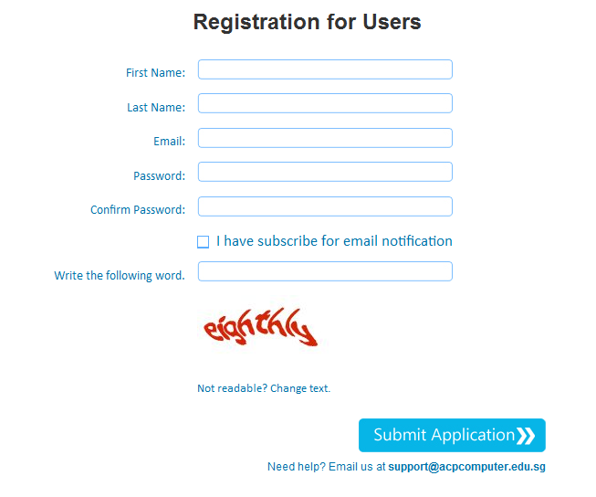

* Table Name : tbl_users
  + - user_id : int(11), AUTO_INCREMENT, Primary Key
    - firstname : varchar(100)
    - lastname : varchar(100)
    - email : varchar(100)
    - password : varchar(100)
    - subscription : int(11)
    - created_on : datetime
    - status : int(11)

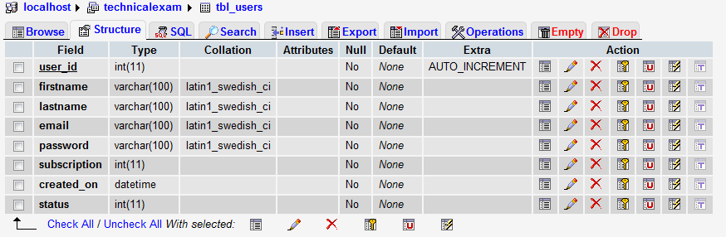

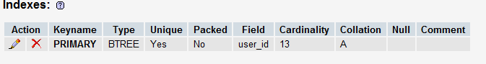

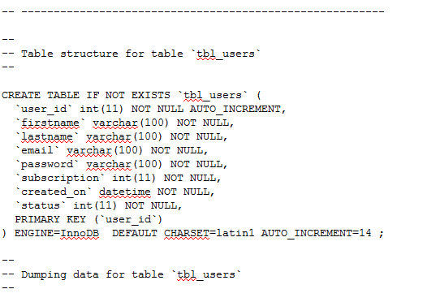

**Step 2:**

Implement captcha in the registration

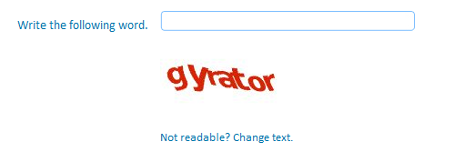

**Step 3:**

Implement email confirmation to complete registration

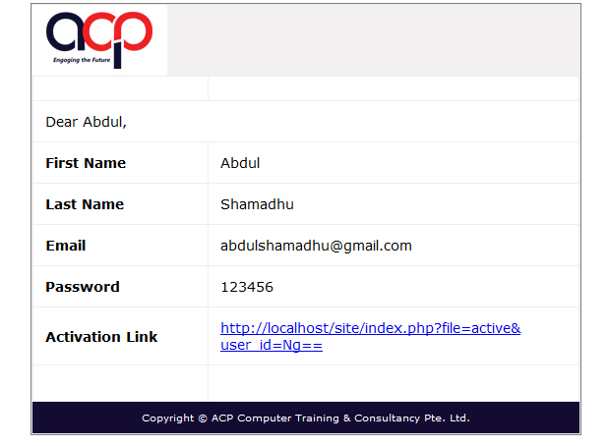

**Step 4:**

Implement a forgot password link

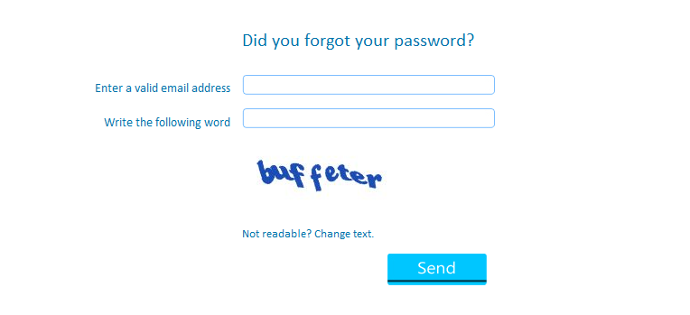

**Step 5:**

Allow user to manage his User Profile (update)

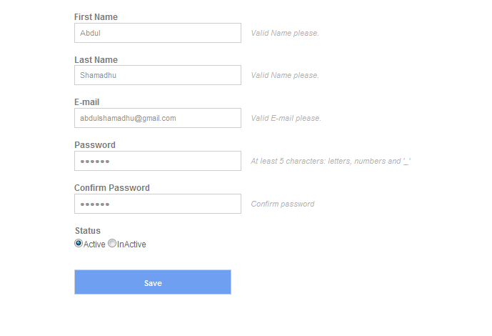

**Step 6:**

* Allow user to unsubscribe from email notification.
* Fields: subscriber_id,title,description,created_on,status

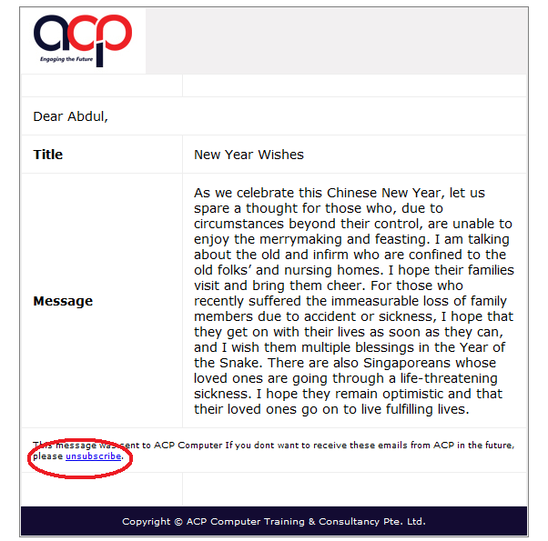

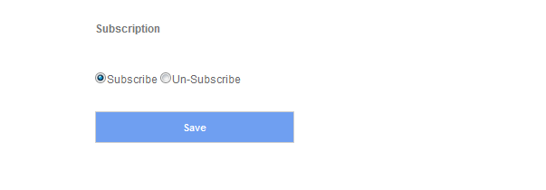

* Table Name : tbl_subscribers
  + - subscriber_id : int(11), AUTO_INCREMENT, Primary Key
    - title : varchar(255)
    - description : text
    - created_on : datetime
    - status : int(11)

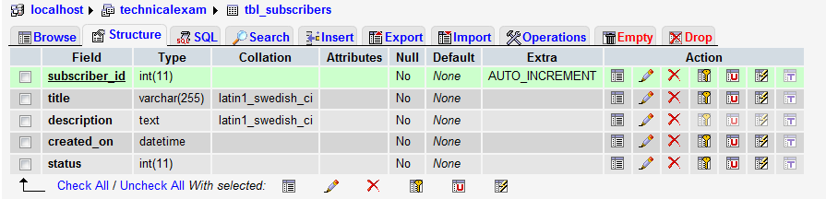

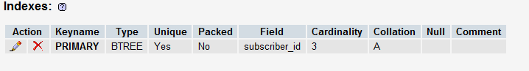

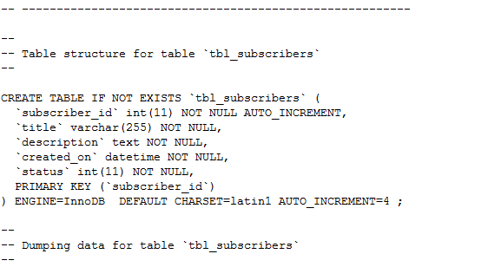

**Administration**

**Step 1:**

* Manage user account - Make account active or inactive - if inactive user will not be able to login

1. **Admin Panel Login Screen**

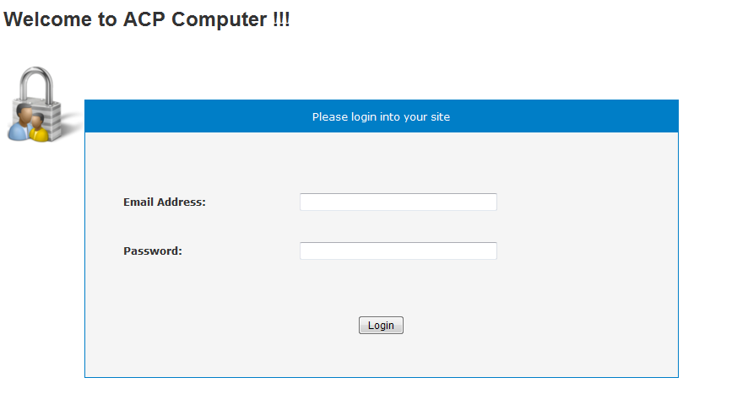

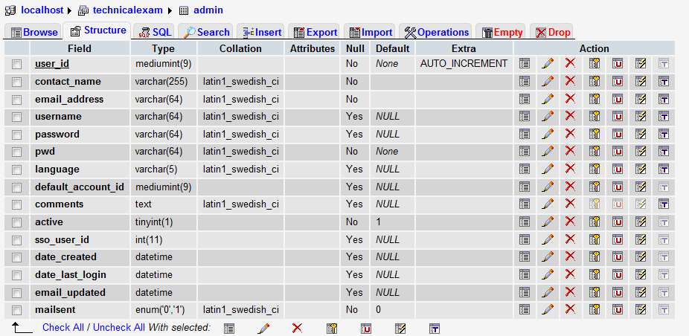

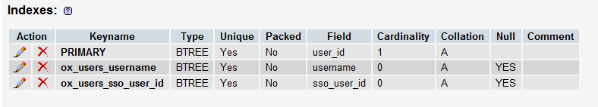

1. **Admin Dashboard Screen**

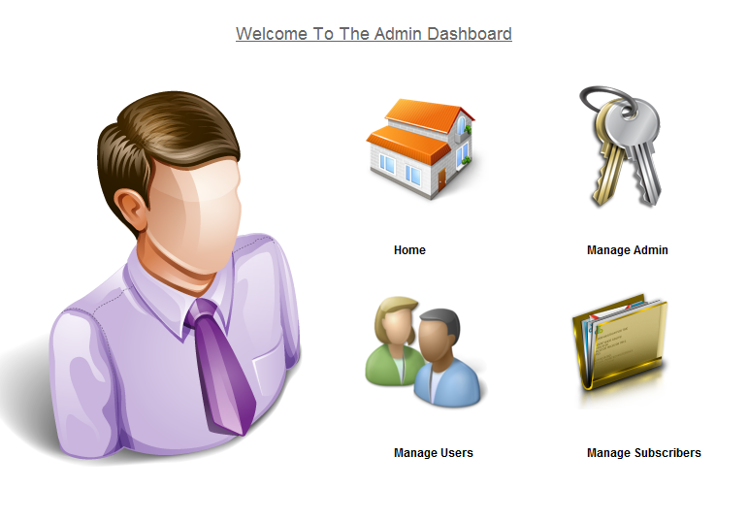

1. **Admin Dashboard Screen**

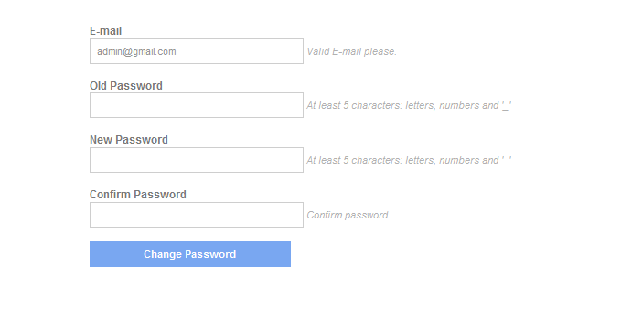

1. **Admin Manage Users List**

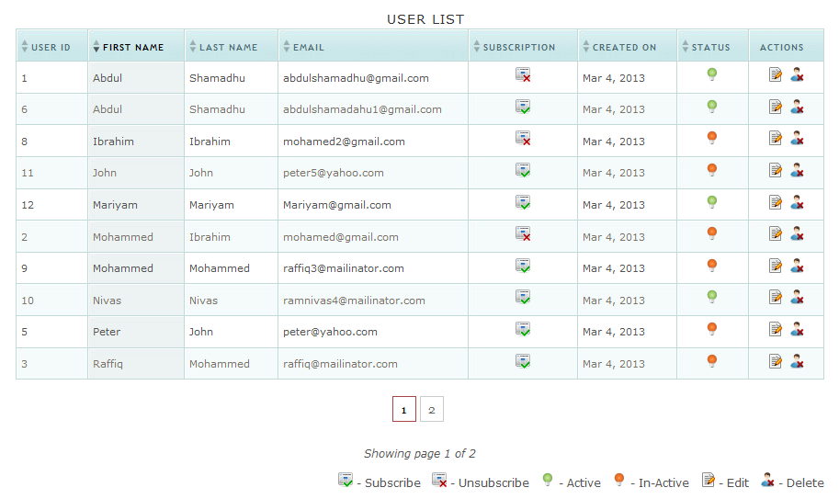

1. **Admin Manage User Edit Screen**

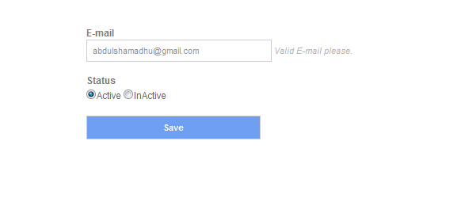

**Step 2:**

* Send email notification (text message) - support mass mailing to subscribers.

1. **Admin Manage Subscribers List Screen**

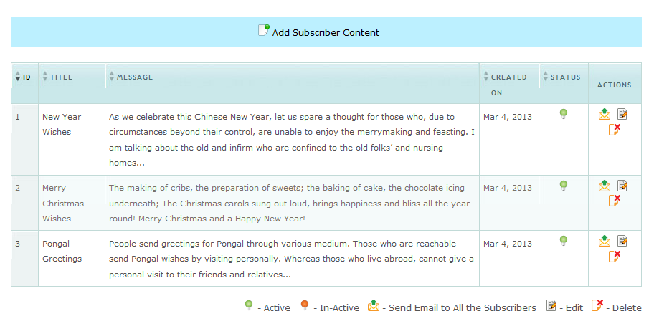

1. **Admin Manage Subscribers Add Screen**

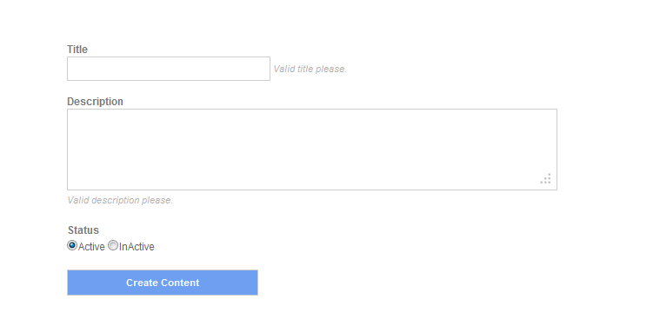

1. **Admin Manage Subscribers Edit Screen**

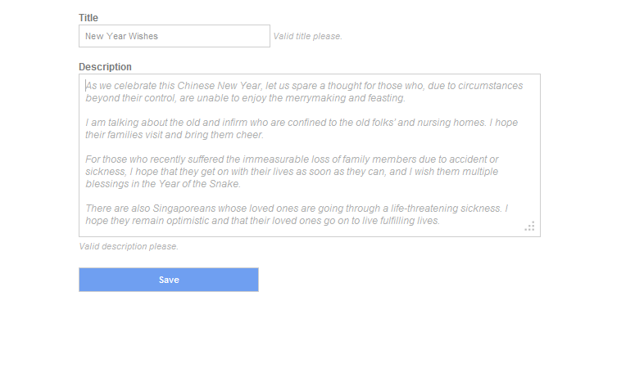

1. **Send email notification (text message) – support mass mailing to subscribers**

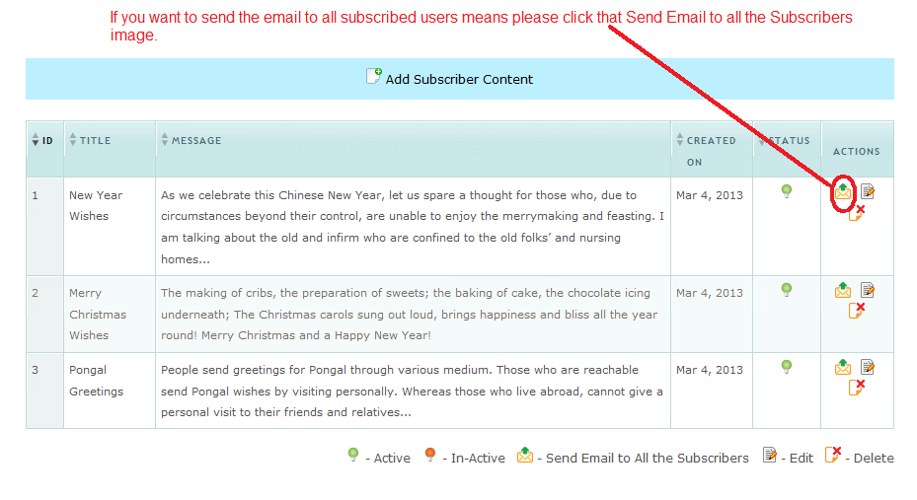

1. **Send email notification (text message)**



1. **Unsubscribe Screen**

